CS 255 System Design Document

UML Diagrams

UML Use Case Diagram

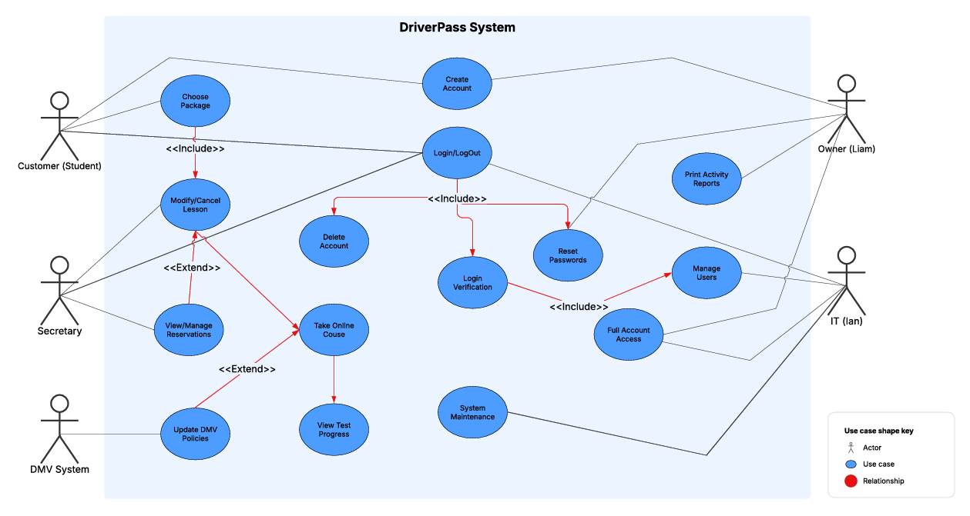

UML Activity Diagrams

LogIn/LogOut
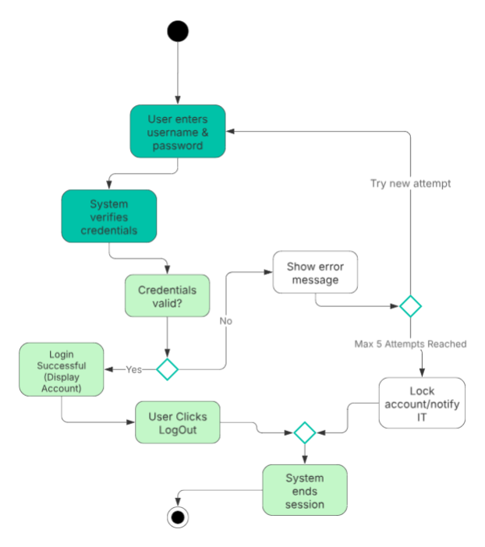

Take Online Course

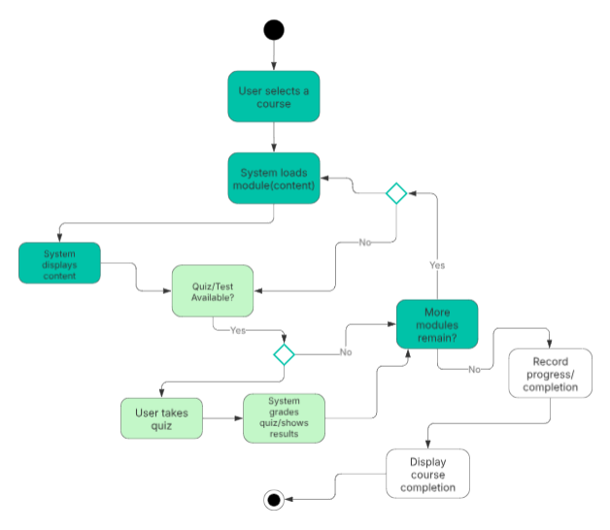

UML Sequence Diagram

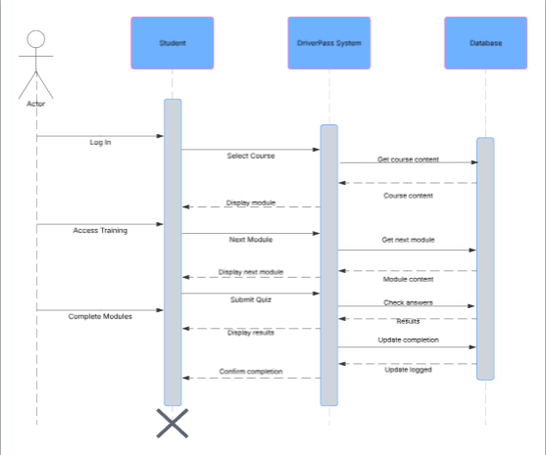

UML Class Diagram

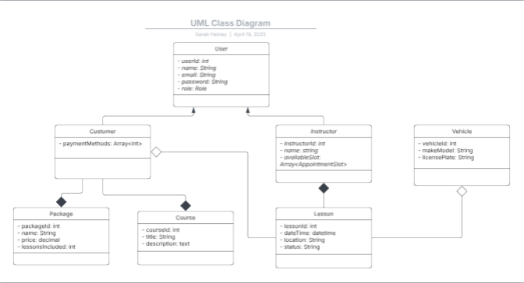

Technical Requirements

- Dedicated hosting server
- Stable internet connection
- Substantial storage capacity
- Network security systems
- Operating system
- DMS
- Security software
- Regional access
- Data Center Hosting
- Geographically strategic server placement

